Crimes with Shooting Encounters in LA

Vignesh Srinivas Ravi Shankar

California State University, Los Angeles

**Data Set URL’s:**

1.Deputy details dataset: https://data.lacounty.gov/Criminal/Deputy-Details-Hit-Shooting-Incidents-and-Non-Hit-/7jc3-gsk7

2.Suspect details dataset: https://data.lacounty.gov/Criminal/Person-Details-Hit-Shooting-Incidents-and-Non-Hit-/t8vk-5p9p

3.All incident types dataset: https://data.lacounty.gov/Criminal/All-Shooting-Incidents-for-Deputy-Involved-Shootin/xutq-azb6

4.Historical Crime data: https://data.lacounty.gov/Criminal/LA-SHERIFF-CRIMES-FROM-2004-TO-2015/3dxh-c6jw (Year 2010-2015)

There are 4 different datasets containing information of total crimes in LA county from year 2010 – 2015 handled by LA Sheriff department, details of Deputy officials, suspects those who were involved in Shooting encounters and the incident types. The incident types are divided into Hit Shooting, Non-Hit Shooting, Animal Shooting, Unintentional discharge shooting and other shootings which are present in dataset3. The deputy details like their race, age, gender, years of service, and the weapon used are present in dataset1. The suspect details like race, age, criminal history, and wounded during incident are present in dataset2. The dataset 4 consists of total crime data, from which we are going to consider only the shooting incidents from year 2010 to 2015. These excel files are saved as SQL server database tables, which is used as a source connection in Tableau.

1. **Data cleaning:**
2. **Embedded Values:** Multiple values entered in one attribute. ‘INCIDENT_DATE’ in Deputy_details table which is having a datetime datatype. Ex: ‘2011-03-10 20:35:00.000’

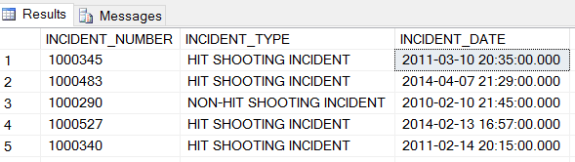

Solution: Split the column into two different columns as ‘Incident date’ and ‘Incident time’ using T-SQL query,

select *,convert(time,INCIDENT_DATE) as Incident_time, convert(date,INCIDENT_DATE) as Incident_day

into [dbo].[New_table] from [dbo].[Old_table]

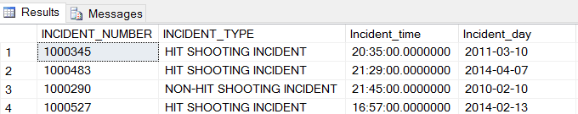

1. **Missing Values:** Unavailable (dummy or null) values during the data entry. ‘DECEASED’ and ‘WOUNDED’ columns in Deputy_details table have value ‘Y’ and null.

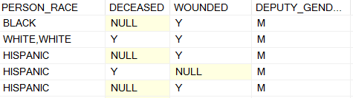

Solution: Modified the table data by entering ‘N’ for NULL values using below T-SQL query,

update [dbo].[Deputy_details] set DECEASED='N' where DECEASED is NULL

update [dbo].[Deputy_details] set WOUNDED='N' where WOUNDED is NULL

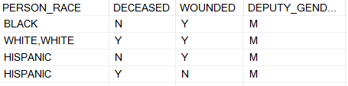

1. **Cryptic values, Abbreviations:** The HANDLING_UNIT_ID column in incidents has values like ‘COM’ which means ‘Compton Station’. But this column is neglected as there is another column called ‘HANDLING_UNIT_NAME’ with the abbreviation.

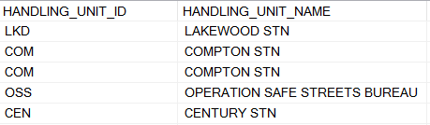

1. **Violated attribute dependencies:** There are no violated attribute dependencies in the data. Example: Each ZIP is associated with corresponding CITY.

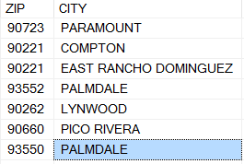

1. 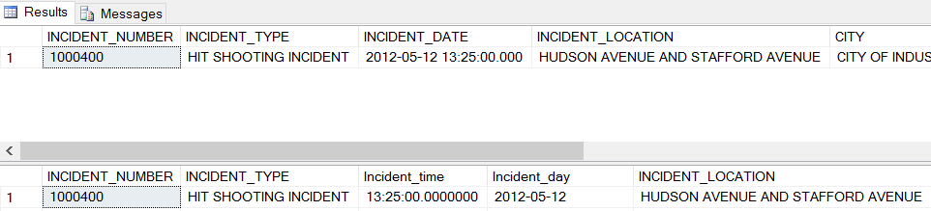**Referential integrity violation:** There are no referential integrity violation. The incident number and their corresponding details in Incidents dataset and deputy details dataset, does have the proper referential integrity.

**Query :** select * from [dbo].[Incidents] where INCIDENT_NUMBER='1000400'

select * from [dbo].[Deputy_details] where INCIDENT_NUMBER='1000400'

1. **Data Visualization:**
2. **What is the total Shooting encounters by year for top 4 incident type?**

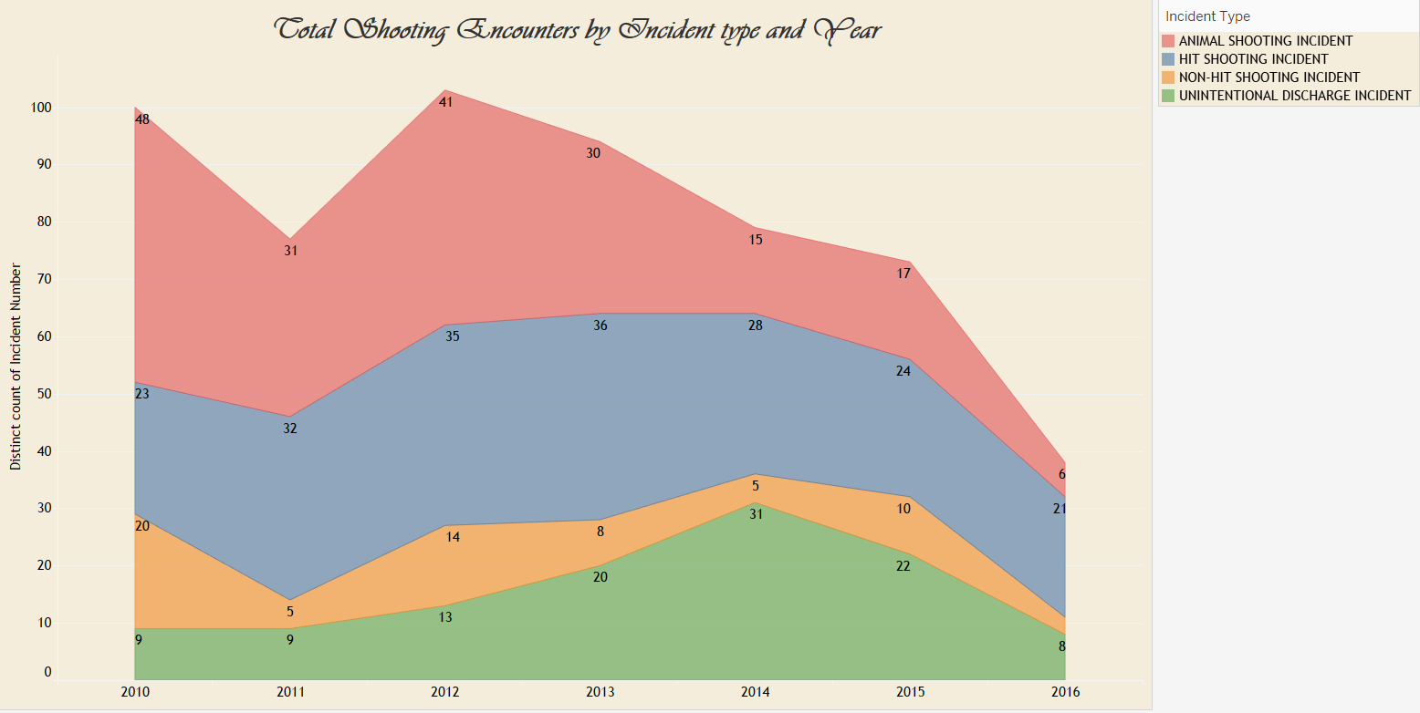

From this Area chart, we observe that the top 4 incident types are Animal shooting incident, Hit shooting incident, Non-hit shooting incident and unintentional discharge incident. For 2016, the data is collected until 2016-10-07. We see that shooting count by deputies were high during 2012 and was decreasing by end of 2016. Also, we observe that Hit shooting and Animal shooting incidents occupies more than 50% of the total shooting counts every year. The below pie chart shows the same information along with shootings by top deputy unit handled every year,

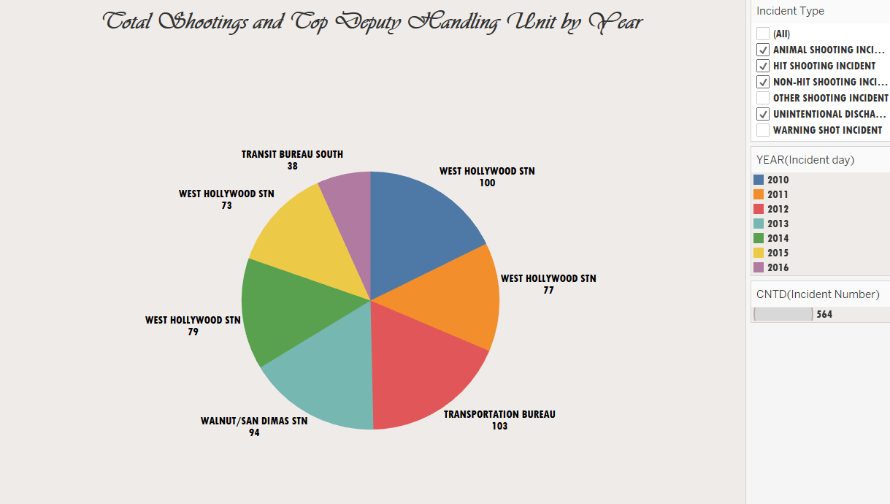

1. **What is the most commonly used weapon category by deputies for the shooting along with Wounded details?**

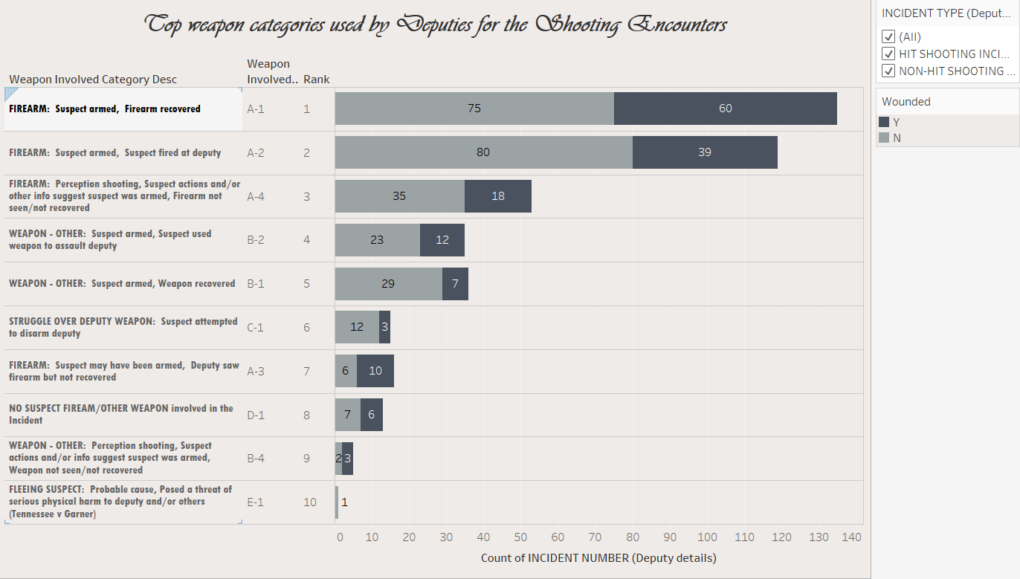

(Applied from the class learning – Rank)

From this horizontal bar chart, we perceive that the weapon category type and their description are arranged based on the rank of total incident count. This includes shootings of only two incident types: Hit shooting and Non-Hit shooting. To know whether the deputy is wounded or not, it is differentiated by colors. Example: Out of 135 incidents involving weapon A1: Suspect armed with firearm – firearm recovered, 60 were wounded and 75 were not wounded.

1. **What are the top cities with number of Hit and Non-hit shooting incident for past 3 years?**

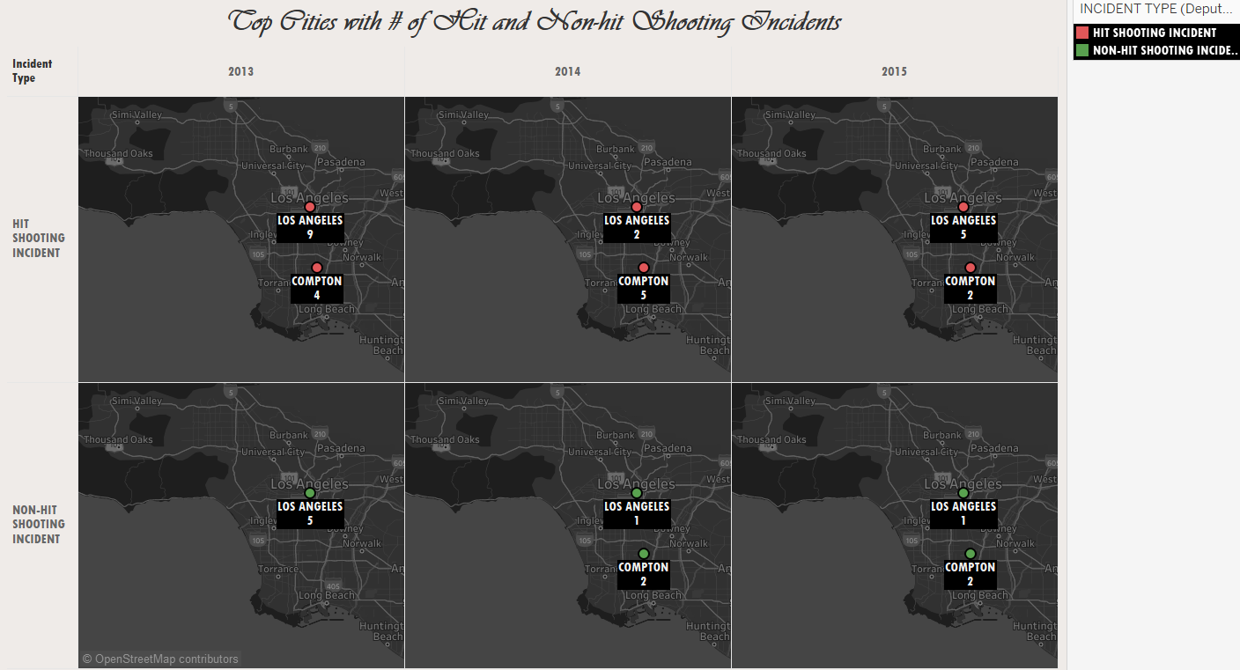

(Applied from the class learning – Geographic Map)

This geographic map tells us the Cities with most shooting encounters for Hit and Non-hit shooting incident. We see that Los Angeles city being the top city with most shooting incidents. We also infer that the total shootings have been declining over the years. Example: There were total of 14 Shooting incidents by deputies in year 2013 for Los Angeles city, while there are only 6 incidents in 2015. Compton is the city next to LA ranking in highest shooting incidents.

1. **What is the total number of deputies involved in shooting w.r.t Years of Service and Person Race?**

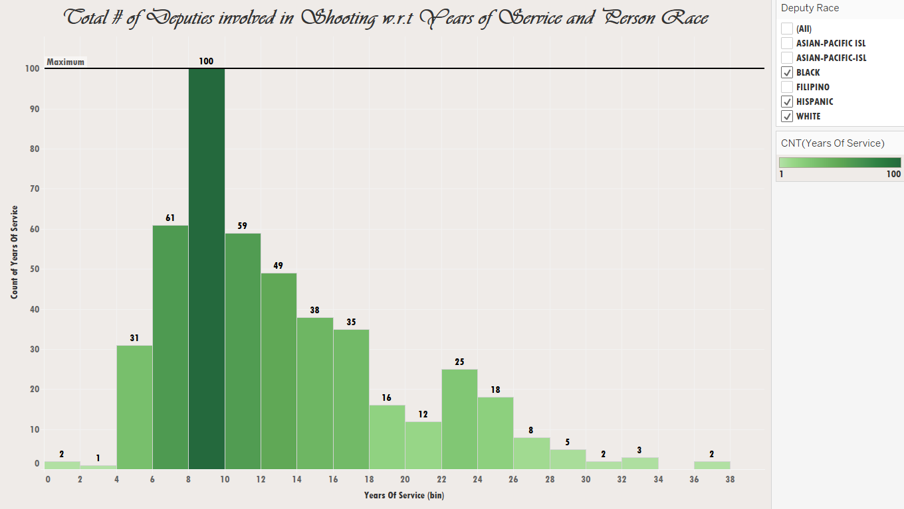

(Applied from the class learning – Bin, Reference line)

This histogram chart denotes the number of deputies involved in shooting with respect to Years of service and filtered by their race – Black, Hispanic and White. The years of service is used as Bin with value 2. We see that deputies with experience between 8 and 10 involved in shooting are 100 which is the maximum. (denoted by a reference line). We also infer that deputies with years of experience between 4 to 18 involved in 70% of the total shootings.

1. **What is the most common age group of victims by also displaying their criminal history?**

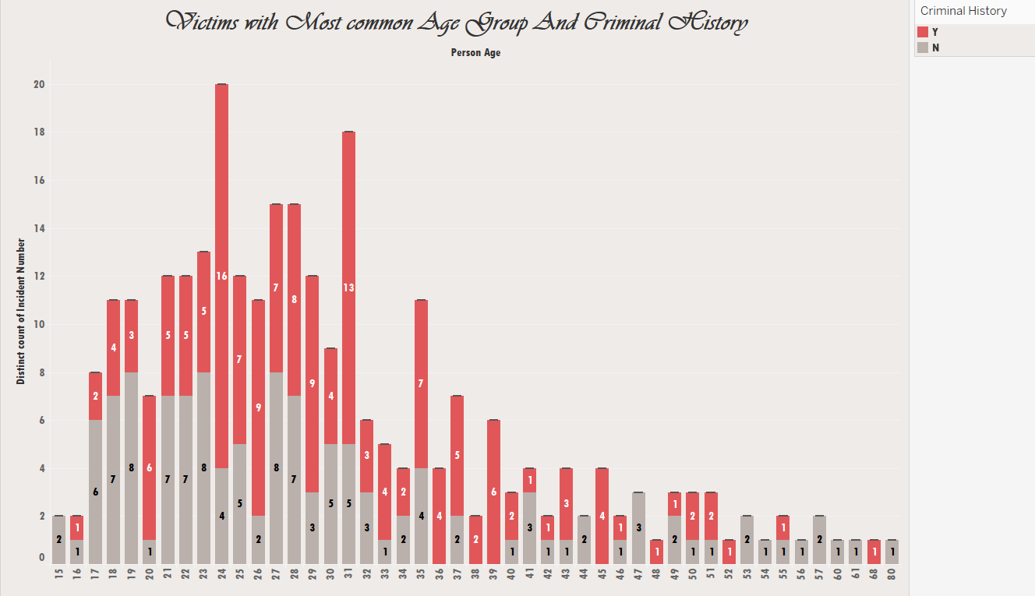

The above stacked bar chart shows the victims with most common age group and denotes if the person has any criminal history before. We infer from the chart that most victims fall in the age group between 23 to 31. The maximum persons with criminal history also falls in the same age range. The youngest victim is of age 15 and the oldest victim is of age 80. The maximum victims (20) involved in shooting encounter with deputy is of age group 24.

1. **What is the total shootings by deputies for Animal shooting and Unintentional discharge incidents based on Gender?**

(Applied from the class learning – Box and whisker plot)

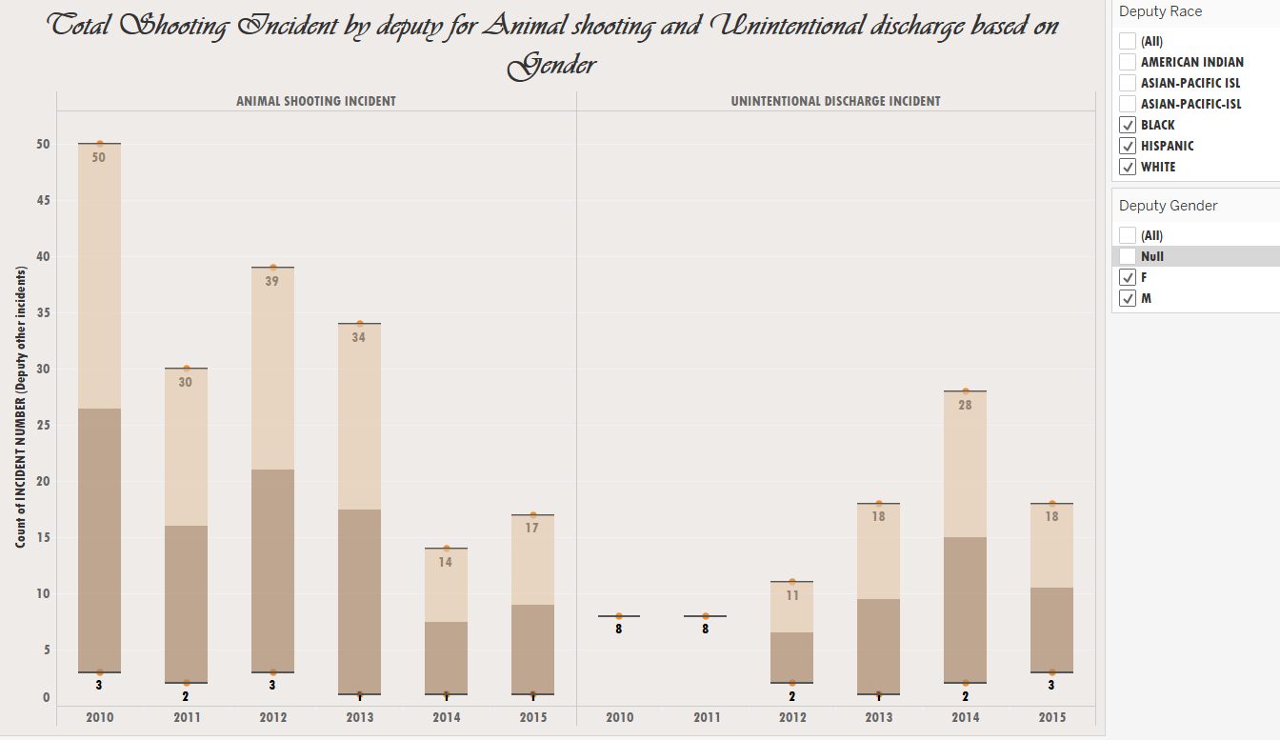

The above box and whisker plot describes the total shootings over 6 years for animal shooting and unintentional discharge incidents. It displays only for the deputy races: Black, Hispanic and White. The shape of the distribution, lower/higher whisker is divided by the Gender (Male for Higher whisker and Female for Lower whisker). The median is calculated for every year. We observe that animal shooting incidents have been declined to half after 2013 and unintentional discharge incidents are erratic over the six years.

1. **What is the ratio of shootings involved in crimes between Deputy vs Victim with the forecast for next 3 years.**

(Applied from the class learning- Group, Forecast, Dates)

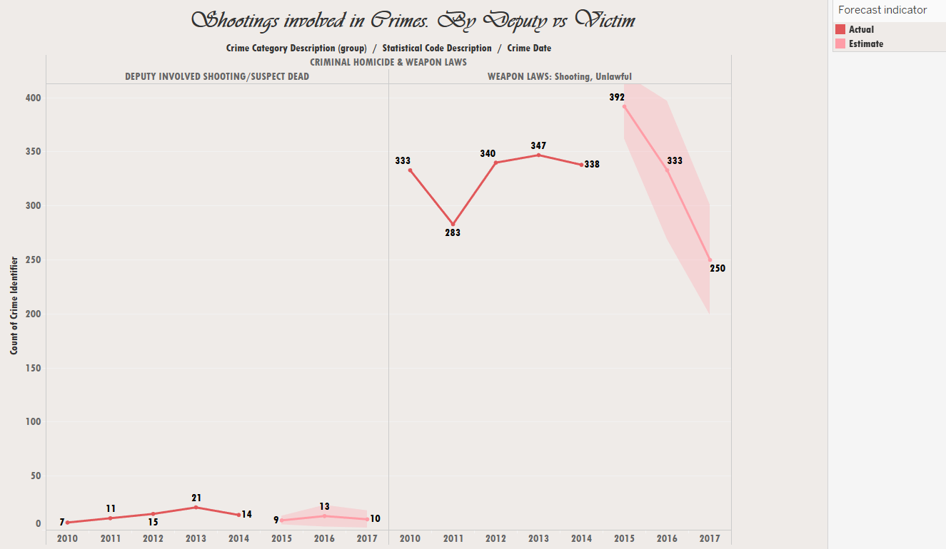

The line chart depicts the comparison between the crime categories - Deputy involved shooting/Suspect dead (Hit shooting incident) and weapon laws:Shooting, Unlawful which are shootings by victims based on the discrete year. A group for crime category description is created to group these two into one and rest to other. The other category is excluded by filter. The forecast for next 3 years is created, and it is observed from the estimate that the shooting crimes are decreasing as per the forecast.

1. **What are the most critical shooting incidents by year?**

(Applied from the class learning- Calculated Field)

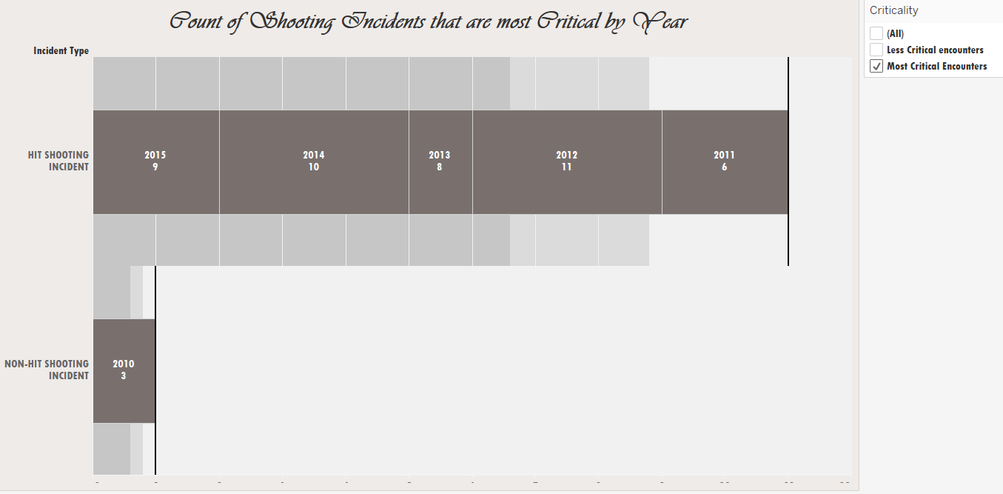

The above bullet chart infers the number of critical incidents by year for Hit and non-Hit shooting incident category. A calculated field is used to get the Most and less critical shooting encounters, which is used in filter. Example: In year 2012, 11 deputies were involved for 3 shooting incidents so they are considered to be critical. The formula for calculated field is: If ([No Of Involved Deputies]>2 and [WOUNDED (Suspect details)]='Y') then 'Most Critical Encounters' else 'Less Critical encounters' end

1. **Dashboard:**

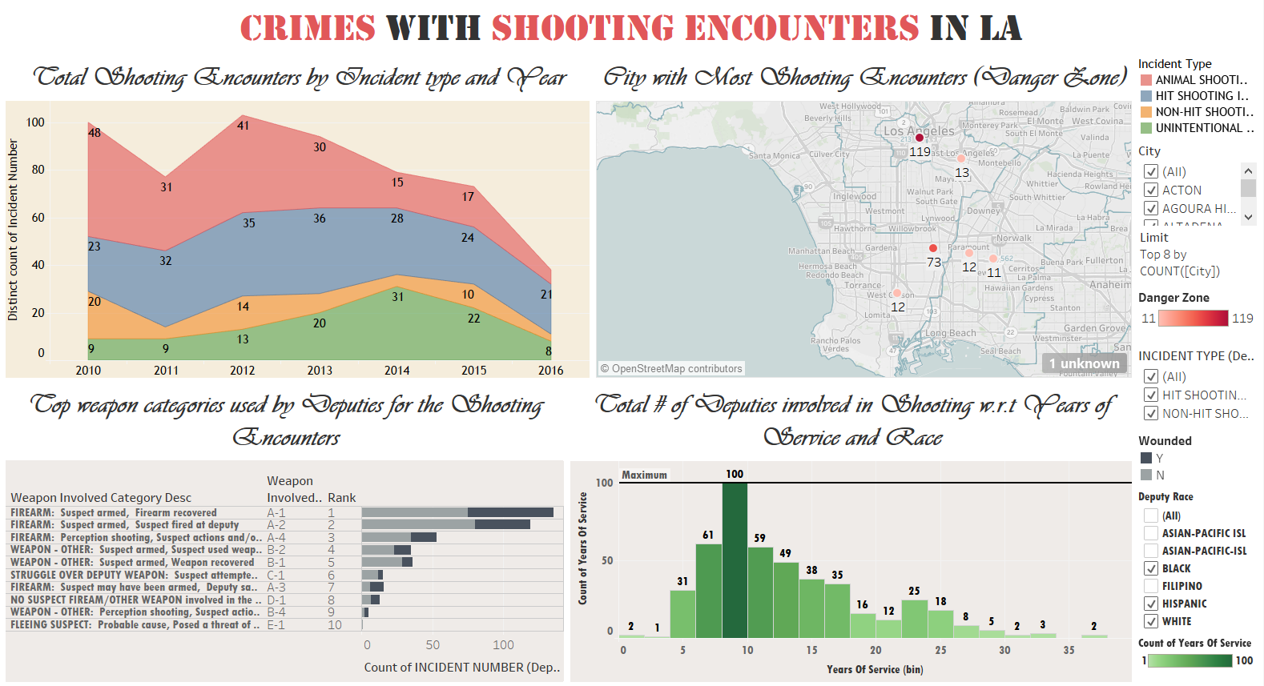

1. **Story telling:**

**Crimes with Shooting Encounters in LA County**

*Gun control means control. It means control for the government and the government starts controlling the people - Luke Scott*

Los Angeles, California is one of the largest metropolitan areas in the country, a port city, and incredibly ethnically diverse. It is within close proximity to the Mexican drug trade, home to the entertainment industry, and has residents across the socio-economic spectrum. Due to these and a combination of other factors, Los Angeles has a colorful history of crime, including organized criminal activity, gang wars, riots, and more. The Crime in Los Angeles has varied throughout time, reaching the peak between 1970s and 1990s. There were also several shooting encounters in the city and there is a report that 80 people shot by police in the year 2015 in Los Angeles County. [1] Per KPCC (Southern California Public Radio Channel) investigation, they found that clear majority of police shootings take place on-duty. The investigation also revealed that no Los Angeles County police officer has been prosecuted for an on-duty shooting by the district attorney since 2000.

As per the statistics by LA Sheriff department, the total shootings involving deputy has been decreasing over past 5 years, reaching peak in 2013. Out of 88 cities in LA county, there are some cities with most deputy involved shooting encounters. These cities were marked as ‘Danger Zone’, as per the shooting statistics for past 5 years. Los Angeles city being ranked No.1 with 119 shootings is followed by City of Compton in No.2 with 73 shootings. These two cities fall in the 40% of the total deputy shootings throughout the LA county for the past 5 years. The deputy involved shooting of the victim fall in the crime category of ‘Criminal homicide’, which in most cases shooting happens only as a self-defense.

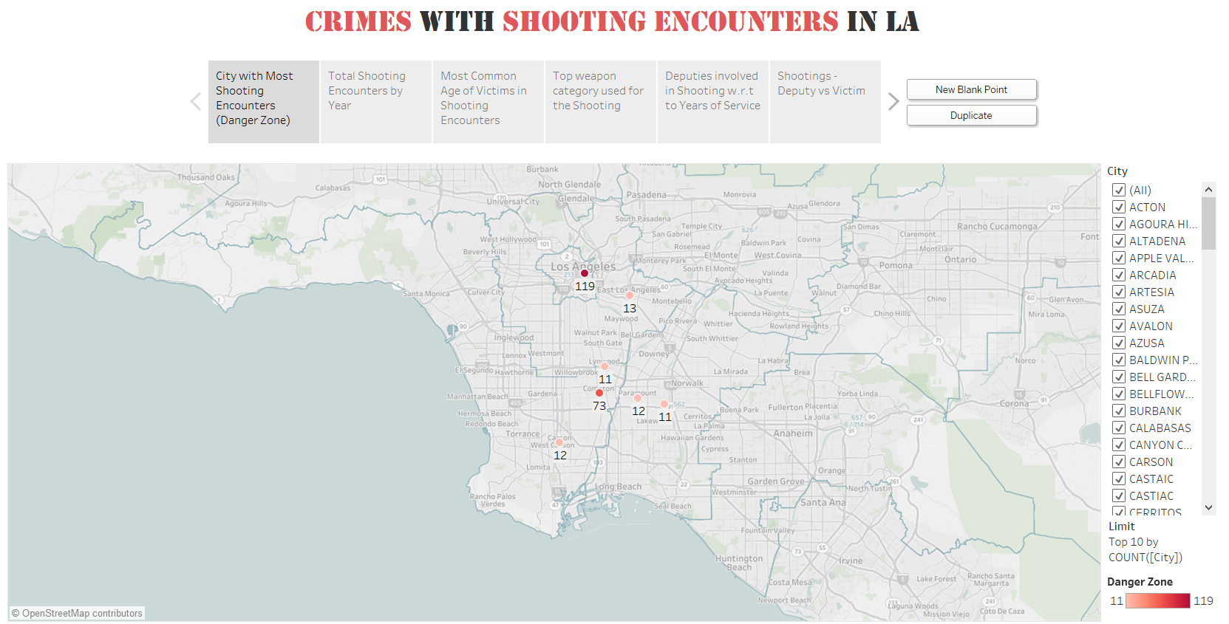

The Deputy involved shooting is categorized into 6 categories. Hit-shooting, Non-hit Shooting, Warning shot, Animal Shooting, Unintentional discharge, and shooting Incident-Other. If any person/deputy is shot, then it comes under hit-shooting incident. If a deputy fires a warning shot and then decides to fire at a person, the incident is classified as either a hit or non-hit shooting incident. On comparing the past 5 year statistics the total deputy involved shooting has been decreasing along with the total shootings involved by the victim. The trend for deputy involved shooting totally depends on the trend of ‘Weapon Law’ category of the victims, as in 95% cases the shooting is initiated by the victims during the arrest.

On comparing the weapon involved categories in the deputy involved shooting encounters, A1 and A2 ranks the top 2 categories. A1 is Suspect armed with firearm –firearm recovered, while A2 is Suspect armed with firearm –suspect fired at deputy. These two categories are the cause for 50% of total shooting encounters involving deputies. On considering the age of the victims, the suspects most common age was between 21 to 31 years who were involved in shooting with the deputies.

For other shooting incidents like, Animal shooting incidents by deputies were found decreasing over the years from 2010 to 2015. Being 53 in 2010, it was only 18 at the end of 2015. It is reported that 480 people have killed by gunshot in Los Angeles county for the past 12 months. [2] These gun murders need to be controlled only by enforcing a strong gun control laws. The Los Angeles and Chicago metropolitan areas had the most gun murders among the nation’s fifty most-populous metropolitan areas in 2009 and 2010, according to a report released by the Centers for Disease Control and Prevention. [3] The shooting encounters by deputies will be reduced only if the gun control amongst the public is effective.

There was a poll conducted by Reuters/Ipsos in December 2015 regarding the importance of Gun control in US, and 70% of the respondents said the gun control needs to be addressed. [4] It is also considered to be one of the principal issues in US election 2016.

Recommendations:

On comparing the past trend, it is understood that, 50% suspects in the deputy involved shooting are of age between 21-31. If proper gun control laws are enforced targeting this age group, we can minimize the gun murders which will eventually decrease the total shootings incidents involving deputies as we see most of the incidents was only self-defensive by the deputies. Researchers conservatively estimate that gun violence costs the American economy at least $229 billion every year [5]. So, taking necessary steps to reduce this will not only reduce the Shooting related crimes in the city, but also the overall economy of the country will be increased.

REFERENCES:

[1] Aaron Mendelson (December 24 2015), More than 80 people shot by police in LA County this year, DA says

Retrieved from <http://www.scpr.org/news/2015/12/24/56407/more-than-80-people-shot-by-police-in-la-county-th/>

[2] LATimes Homicide report, recently updated (October 20 2016)

Retrieved from <http://homicide.latimes.com/cause/gunshot>

[3] Terence P. Jeffrey (August 2, 2013),L.A., Chicago Rank 1 and 2 for Gun Murders; N.O. Has

Highest Rate

Retrieved from http://www.cnsnews.com/news/article/la-chicago-rank-1-and-2-gun-murders-no-has-highest-rate

[4] WGNO Web Desk (February 10, 2016), New CDC study: Louisiana #1 for most shooting deaths in the country

Retrieved from <http://wgno.com/2016/02/10/the-15-states-with-the-most-gun-deaths/>

[5] Mark Follman, Julia Lurie, Jaeah Lee & James West, The True Cost of Gun Violence in America (2015),

Retrieved from http://www.motherjones.com/politics/2015/04/true-cost-of-gun-violence-in-america